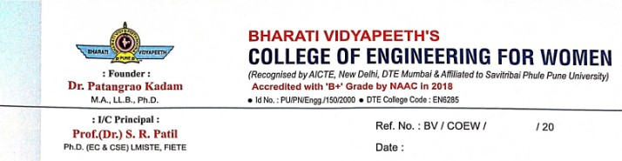

NAAC SSR CYCLE- 2

6.5.1_1 LINKS

Sr. No. | Particulars | Supporting Documents
1. | Academic Calendar 2018-19 | View File
2. | Academic Calendar 2019-20 | View File
3. | Academic Calendar 2020-21 | View File
4. | Academic Calendar 2021-22 | View File
5. | Academic Calendar 2022-23 | View File
6. | SDO | View File
7. | NSS | View File
8. | Sports & Gymkhana | View File
9. | Magazine | View File

